**Login page with Frame Set(20-01.html):**

<html>

<head><title>task</title>

<meta name="viewport" content="width=device-width, initial-scale=1">

<link rel="stylesheet" href="https://stackpath.bootstrapcdn.com/bootstrap/4.4.1/css/bootstrap.min.css" >

<script src="https://code.jquery.com/jquery-3.4.1.slim.min.js" ></script>

<script src="https://cdn.jsdelivr.net/npm/popper.js@1.16.0/dist/umd/popper.min.js"></script>

<script src="https://stackpath.bootstrapcdn.com/bootstrap/4.4.1/js/bootstrap.min.js"></script>

<link rel="stylesheet" href="https://cdnjs.cloudflare.com/ajax/libs/animate.css/3.7.2/animate.min.css">

</head>

<frameset cols="55%,45%">

<frame name="left" src="right.html"/>

<frame name="right" target="_self" src="login.html"/>

</frameset>

</html>

**Login.html-**

<!DOCTYPE html>

<html lang="en">

<head>

<title>Login</title>

<meta charset="UTF-8">

<meta name="viewport" content="width=device-width,intial-scale=1">

<link rel="icon" type="image/png" href="favicon.jpg"/>

<link rel="stylesheet" type="text/css" href="util.css">

<link rel="stylesheet" type="text/css" href="main.css">

<link rel="stylesheet" href="https://cdnjs.cloudflare.com/ajax/libs/font-awesome/4.7.0/css/font-awesome.min.css">

<script >

src="https://use.fontawesome.com/releases/v5.5.0/css/all.css";

</script>

</head>

<body style="background:black;">

<div class="container-login100">

<div class="wrap-login100 p-l-110 p-r-110 p-t-70 p-b-33">

<img src = "enter.png" class="logobox">

<form class="login100-form validate-form flex-sb flex-w">

<span class="login100-form-title p-b-2">Member Login

</span>

<div class="w-full text-center">

<span class="txt2">

Don't have an account?

</span>

<a href="C:\Users\Srinivas-pc\Desktop\reg\screenreg.html"target="_blank" class="txt2 bo1">

Sign up now</a>

</div>

<div class="p-t-20 p-b-9">

<span class="txt1">

<i class="fas fa-user"></i>

Email

</span>

</div>

<div class="wrap-input100" style="position: relative;" data-validate = "Username is required">

<input class="input100" type="email" name="username" >

</div>

<div class="p-t-13 p-b-9">

<span class="txt1">

<i class="fas fa-lock"></i>

Password

</span>

</div>

<div class="wrap-input100" style="position: relative;" data-validate = "Password is required">

<input class="input100" type="password" name="pass" >

</div>

<div class=" p-t-13 p-b-9">

<input type="checkbox" >Keep me signed in

</div>

<a href="#" class="p-t-13 p-b-9 txt2 bo1 m-l-5">

Forgot password?

</a>

<div class="m-t-17" style="width: 100%;">

<button class="login100-form-btn">

Sign In

</button>

<br>

</div>

<br><br><br><br>

<div class="text-center social-btn">

&nbsp;&nbsp;&nbsp;&nbsp;&nbsp;&nbsp;&nbsp;&nbsp;&nbsp;&nbsp;&nbsp;&nbsp;&nbsp;&nbsp;&nbsp;&nbsp;

<a href="https://www.facebook.com" class="btn btn-primary" style="font-size:25px;color:#FFFFFF"><i class="fa fa-facebook-square"></i>&nbsp;</a>

<a href="https://twitter.com" style="font-size:25px;color:#FFFFFF"><i class="fa fa-twitter"></i>&nbsp;</a>

<a href="https://www.google.com/gmail" style="font-size:25px;color:#FFFFFF"><i class="fab fa-google"></i>&nbsp;</a>

</div>

</div>

</form>

</div>

</div>

</body>

</html>

<html>

<head>

</head>

<body>

<img src="pic.jpg" width="100%" height="100%">

</body>

</html>

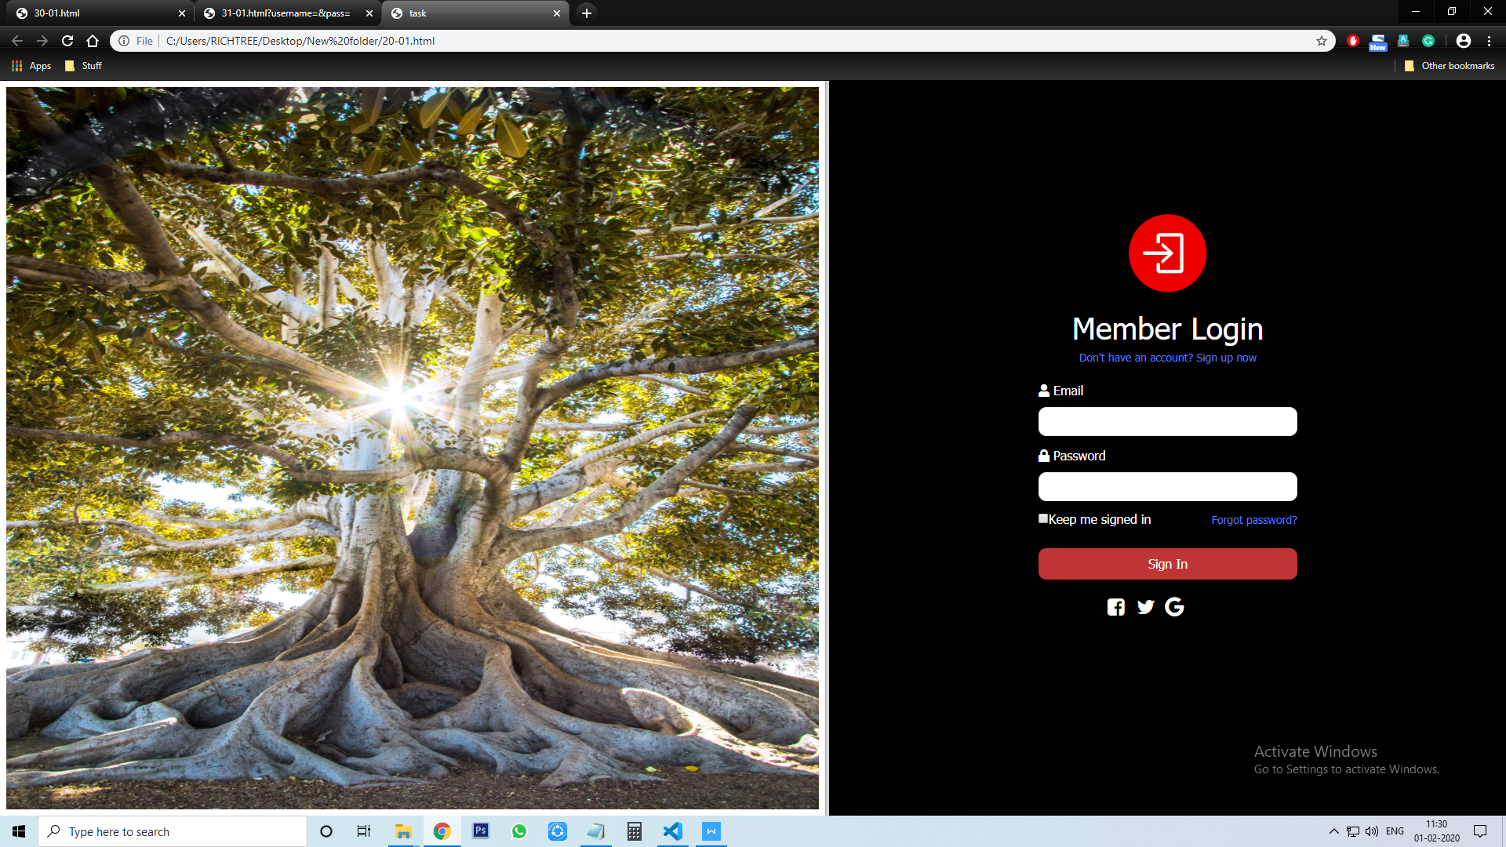

**Registration page(reg.html):**

<html lang="en">

<head>

<meta charset="UTF-8">

<meta name="viewport" content="width=device-width, initial-scale=1.0">

<meta http-equiv="X-UA-Compatible" content="ie=edge">

<title>REGISTRATION</title>

<link rel="stylesheet" href="screenreg.css">

<link rel="icon" type="image/png" href="favicon.png"/>

</head>

<body style="background: black;">

<div class ="Container">

<img src="r.png" alt="icon" >

<h2>Register member</h2>

<a href="login.html" target="_self">Already have an account? Sign in!</a>

<div class="container-block">

<form action="">

<input type="text" name="" id="" placeholder="Full Name">

<input type="text" placeholder="Email">

<input type="password" placeholder="Password">

<input type="password" placeholder="Confirm Password">

<p>By creating an account, you agree our <a href="T&P.html"> Terms & Privacy Policy</a></p>

<input type="Submit" name="Sign up" value="Sign up">

</form> </div></div></body></html>

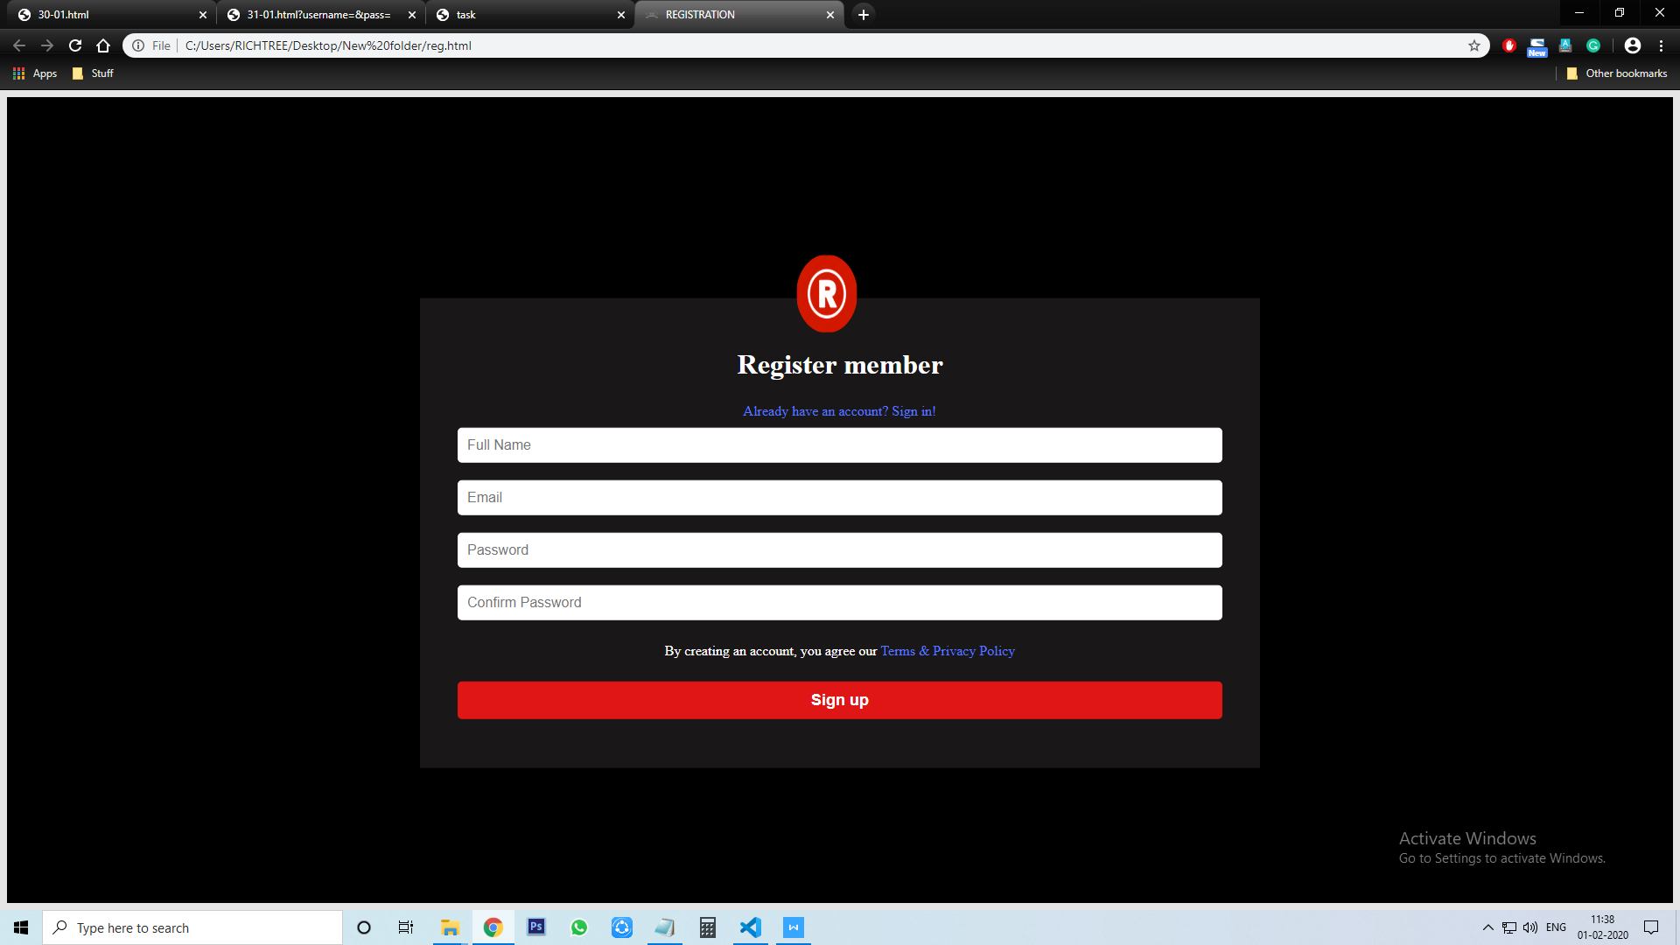

**Login page In Bootstrap(30-01.html):**

<!DOCTYPE html>

<html lang="en">

<head>

<meta charset="utf-8">

<meta name="viewport" content="width=device-width,intial-scale=1,shrink-to-fit=no">

<link rel="stylesheet" type="text/css" href="https://stackpath.bootstrapcdn.com/font-awesome/4.7.0/css/font-awesome.min.css">

<link rel="stylesheet" href="https://maxcdn.bootstrapcdn.com/bootstrap/4.4.1/css/bootstrap.min.css">

<link rel="stylesheet" type="text/css" href="https://stackpath.bootstrapcdn.com/font-awesome/4.7.0/css/font-awesome.min.css">

<script src="https://ajax.googleapis.com/ajax/libs/jquery/3.4.1/jquery.min.js"></script>

<script src="https://cdnjs.cloudflare.com/ajax/libs/popper.js/1.16.0/umd/popper.min.js"></script>

<script src="https://maxcdn.bootstrapcdn.com/bootstrap/4.4.1/js/bootstrap.min.js"></script>

<link rel="stylesheet" href="30-1.css">

</head>

<body>

<div class="container-fluid">

<div class="row">

<div class="col-lg-6 col-md-6 login-sec"></div>

<div class="col-lg-6 col-md-6 banner-sec">

<div class="login">

<form class="" action="login.html" method="post">

<h2>login form</h2>

<label for="">email:</label>

<input class="txtb" type="text" name="" value=""><br>

<label for="">password:</label>

<input class="txtb" type="text" name="" value=""><br>

<input type="checkbox" name="" value="">

<span>Remamber me</span><br>

<input class="btn" type="button" name="" value="ok">

</form>

</div>

</div>

</div>

</div>

</body>

</html>

**CSS:**

.banner-sec{

background-size: cover;

height:100vh;

}

.login-sec{

background:url(pic.jpg);

background-color: white;

display: flex;

justify-content: center;

background-size: cover;

}

.login{

position:fixed;

overflow: hidden;

width: 100%;

max-width: 500px;

right:0;

margin: 0;

background:;

height: 100%;

z-index:1;

}

.login form{

text-align:center;

margin:160px,30px;

float:left;

}

.txtb{

width:100%;

padding:8px 0;

font-size: 18px;;

}

.login h2{

font-size: 30px;

color:#f44336;

}

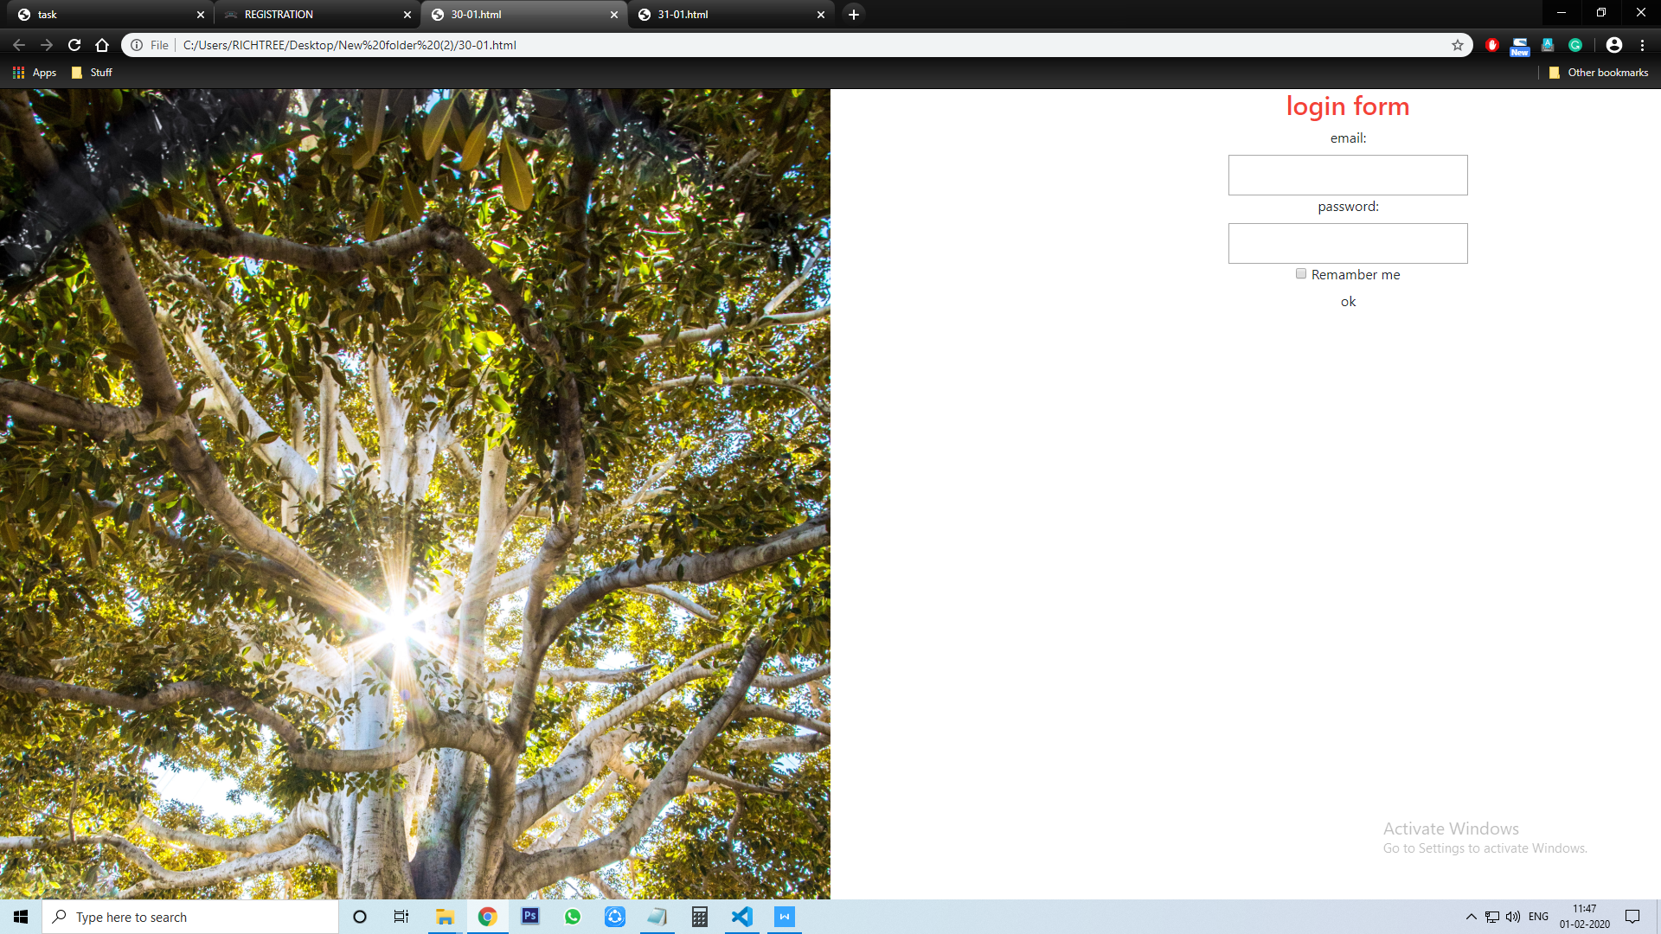

**Login page In Bootstrap with Responsive(31-01.html):**

<!DOCTYPE html>

<html lang="en">

<head>

<meta charset="utf-8">

<meta name="viewport" content="width=device-width,intial-scale=1,shrink-to-fit=no">

<link rel="stylesheet" type="text/css" href="util.css">

<link rel="stylesheet" type="text/css" href="main.css">

<link rel="stylesheet" type="text/css" href="https://stackpath.bootstrapcdn.com/font-awesome/4.7.0/css/font-awesome.min.css">

<link rel="stylesheet" href="https://maxcdn.bootstrapcdn.com/bootstrap/4.4.1/css/bootstrap.min.css">

<link rel="stylesheet" type="text/css" href="https://stackpath.bootstrapcdn.com/font-awesome/4.7.0/css/font-awesome.min.css">

<script src="https://ajax.googleapis.com/ajax/libs/jquery/3.4.1/jquery.min.js"></script>

<script src="https://cdnjs.cloudflare.com/ajax/libs/popper.js/1.16.0/umd/popper.min.js"></script>

<script src="https://maxcdn.bootstrapcdn.com/bootstrap/4.4.1/js/bootstrap.min.js"></script>

**<link rel="stylesheet" href="30-1.css">**

**<link rel="stylesheet" href="main.css">**

**<link rel="stylesheet" href="util.css">**

</head>

<body>

<div class="container-fluid">

<div class="row">

<div class="col-lg-6 col-md-6 login-sec"></div>

<div class="col-lg-6 col-md-6 banner-sec teja">

<div class="login">

<div class="container-login100">

<div class="wrap-login100 p-l-110 p-r-110 p-t-70 p-b-33">

<img src = "enter.png" class="logobox">

<form class="login100-form validate-form flex-sb flex-w">

<span class="login100-form-title p-b-2">Member Login

</span>

<div class="w-full text-center">

<span class="txt2">

Don't have an account?

</span>

<a href="C:\Users\Srinivas-pc\Desktop\reg\screenreg.html"target="_blank" class="txt2 bo1">Sign up now </a>

</div>

<div class="p-t-20 p-b-9">

<span class="txt1">

<i class="fas fa-user"></i> Email</span>

</div>

<div class="wrap-input100" style="position: relative;" data-validate = "Username is required">

<input class="input100" type="email" name="username" >

</div>

<div class="p-t-13 p-b-9">

<span class="txt1">

<i class="fas fa-lock"></i>Password

</span>

</div>

<div class="wrap-input100" style="position: relative;" data-validate = "Password is required">

<input class="input100" type="password" name="pass" >

</div>

<div class=" p-t-13 p-b-9">

<input type="checkbox" >Keep signed in

<a href="#" class="p-t-13 p-b-9 txt2 bo1 m-l-5">

Forgot password?

</a></div>

<div class="m-t-17" style="width: 100%;">

<button class="login100-form-btn">

Sign In

<br><br>

</button>

</div>

</div>

</form>

</div>

</div> </div> </div> </div> </div> </body>

</html>

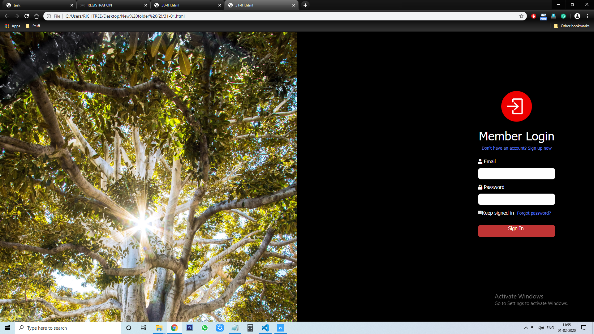

RESPONSIVE LOGIN FORM:

